Park Management Plans and Park Development

Glasgow Botanic Gardens

Public Consultation



November – December 2010

Produced by
Stephen Frew
Corporate Policy Officer
Chief Executive’s Office

Tel: 0141 287 0242
Email: stephen.frew@glasgow.gov.uk

Contents

- Background 3

- Park Usage 3

- Park Safety 6

- Park Information and Features 8

- Park Events 10

- Park Activities 11

- Park Management and Priorities 12

- Parks Management Plans 13

- Park Development 15

- About You 16

1. Background
The Council's Land and Environmental Services carried out a consultation on draft Park Management Plans for seven city parks. A Park Management Plan is required to make an application for the Green Flag Award® scheme.

The Green Flag Award® scheme is the benchmark national standard for parks and green spaces in Scotland, England and Wales. It was first launched in 1996 to recognise and reward the best green spaces in the country.

The Management Plans were available online through the Council’s website (www.glasgow.gov.uk) and within the local area of each of the parks involved. Responses were welcomed from both the general public and other interested stakeholders both locally and nationally.

Response Rate:
Online (www.glasgow.gov.uk) – 22
Kibble Palace - 15
Hillhead Library - 11

Total Response - 48

2. Park Usage

Question 1a: In general, what do you normally use the Park for? (select all that apply)

Activity | Number | Percentage (%)
Recreation – Cycling | 9 | 19%
Recreation – Walking | 45 | 96%
Recreation – Other | 15 | 32%
Recreation – Dog Walking | 2 | 4%
Route to Work/Education | 4 | 8%
Route to Shops | 14 | 30%
Route to other activities | 9 | 19%
Do not use the park | 1 | 2%
Other | 11 | 23%
Base: 47

Question 1b: If other, please specify

A number of other activities were highlighted by respondents, including the use of the play park and, as expected, the glasshouse and botanical collection.

Question 2: Thinking about your main use of the Park, how often do you use it?
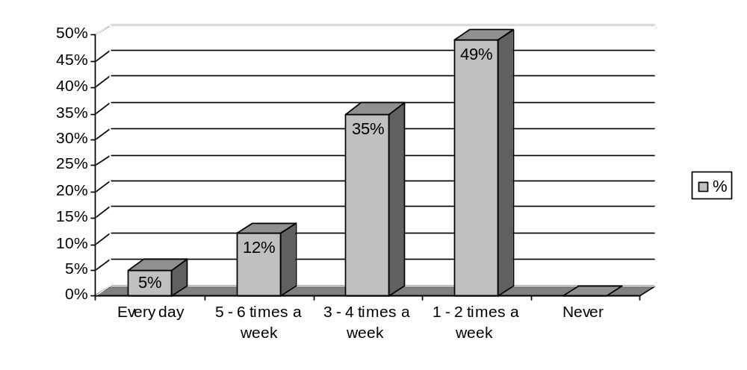 Base: 43

Question 3a: Would you consider your use of the park to be seasonal?

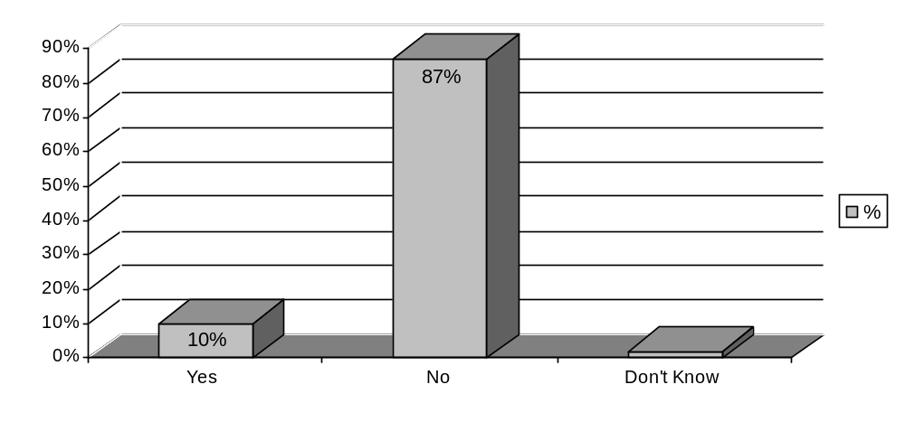Base: 48

Question 3b: If yes, when are you most likely to use the park? (tick all that apply)
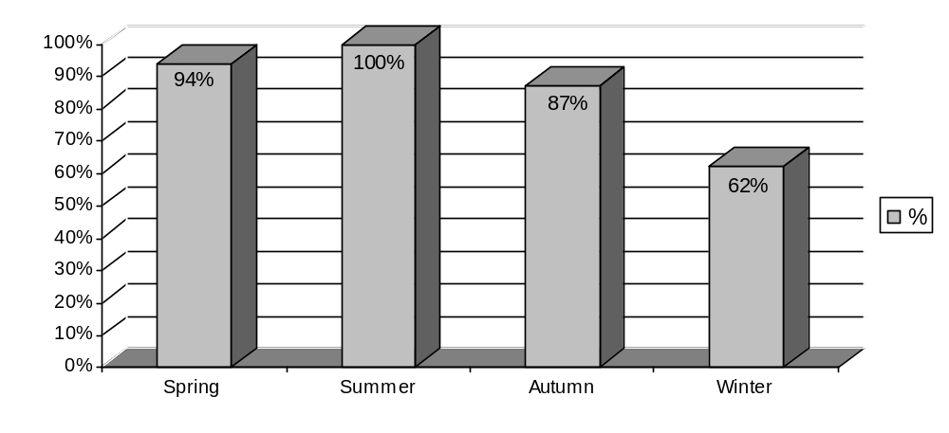Base: 16

3. Park Safety

Question 4a: How welcoming or otherwise would you say the park is?

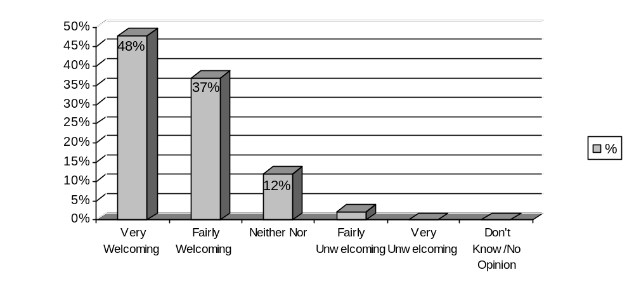Base: 48

Question 4b: If unwelcoming, please provide details

A few issues were identified which respondents felt made the park unwelcoming including a lack of appropriate signage and catering facilities.

Question 5: How safe or otherwise do you feel in the park?

Time | Very Safe (%) | Fairly Safe (%) | Neither Nor (%) | Fairly Unsafe (%) | Very Unsafe (%) | Do not use park at this time (%) | Don’t Know (%)
Morning | 26  (54%) | 16  (33%) | 1  (2%) | 1  (2%) | - | 3  (6%) | 1  (2%)
Afternoon | 27  (57%) | 18  (38%) | 1  (2%) | 1  (2%) | - | - | -
Evening | 8  (18%) | 18  (40%) | 5  (11%) | 1  (2%) | 1  (2%) | 10  (22%) | 2  (4%)
Base: 48

Question 6: In your opinion, how much of an issue, or otherwise, are the following in the park?

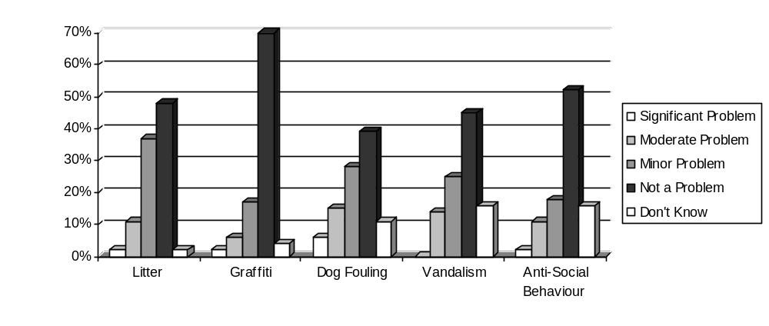 Base: 48

Question 7: Are there any other issues which you feel are a problem?

Respondents highlighted the issue of safety and anti-social behaviour as potential problems within the park. Respondents either did not visit the park at specific times or days, or only visited it when accompanied by others.

Other issues mentioned included more facilities being required, driving within the park boundaries and litter, particularly in the River Kelvin.
4. Park Information and Features

Question 8: To what extent do you agree or disagree with the following statements regarding information provision WITHIN and SURROUNDING the park?

 | Strongly Agree (%) | Agree (%) | Neither Nor (%) | Disagree (%) | Strongly Disagree (%) | Don’t Know (%)
There are sufficient signs providing direction WITHIN the park | 12  (28%) | 22  (51%) | 5  (12%) | 4  (9%) | - | -
There are sufficient signs providing direction in the area SURROUNDING the park | 5  (12%) | 16  (39%) | 15  (37%) | 3  (7%) | - | 2  (5%)
There is sufficient  information about specific features WITHIN the park | 8  (19%) | 22  (51%) | 8  (19%) | 5  (12%) | - | -
Base: 43

Question 9: How would you rate the following aspect of the park in terms of their maintenance?

 | Very Good (%) | Good (%) | Neither Nor (%) | Poor (%) | Very Poor (%) | Don’t Know (%)
Grass | 28 (65%) | 15 (35%) | - | - | - | -
Trees | 28 (65%) | 14 (33%) | - | - | - | 1 (2%)
Shrubs | 26 (60%) | 12 (28%) | 4 (9%) | - | - | 1 (2%)
Bedding Displays | 26 (60%) | 16 (37%) | 1 (2%) | - | - | -`
Paths | 22 (51%) | 20 (46%) | 1 (2%) | - | - | -
Trails | 19 (45%) | 14 (33%) | 6 (14%) | - | - | 3 (7%)
Seats/Benches | 23 (53%) | 16 (37%) | 4 (9%) | - | - | -
Base: 44

Question 10: Do you agree or disagree with the introduction of more natural features within the park?

 | Strongly Agree (%) | Agree (%) | Neither Nor (%) | Disagree (%) | Strongly Disagree (%) | Don’t Know (%)
Wild Flower Meadows | 23  (53%) | 14 (33%) | 4  (9%) | 2  (5%) | - | -
Wetland Creation | 18  (41%) | 12  (27%) | 6  (14%) | 7  (16%) | 1  (2%) | -
Long Grass (Wildlife) | 20  (48%) | 13  (31%) | 7  (17%) | 2  (5%) | - | -
Bird/Bat Boxes | 25  (57%) | 16  (36%) | 2  (4%) | - | 1  (2%) | -
Hedgerows | 16  (38%) | 16  (38%) | 6  (14%) | 3  (7%) | 1  (2%) | -
Base: 45

5. Park Events

Question 11: How do you feel about the current number of events held in the park?

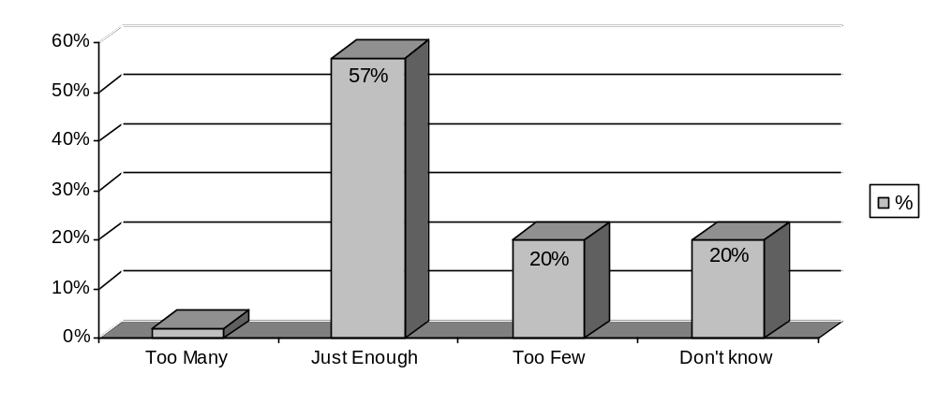Base: 44

Question 12a: Which of the following types of events, if any, do you think there should be more of in the park? (Glasgow Show, Great Scottish Run, galas and fun fairs) (tick all that apply)

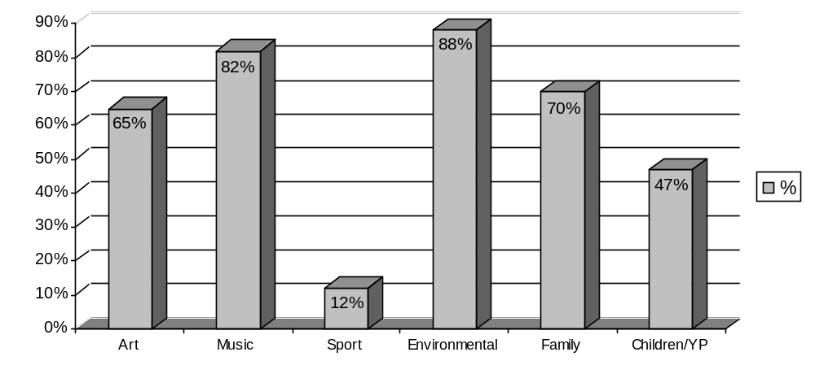 Base: 17

Question 12b: Other, please specify

Other events mentioned include firework displays, events for older people and botanical/horticultural tours.
6. Park Activities

Question 13: How do you feel about the current number of activities available in the park?

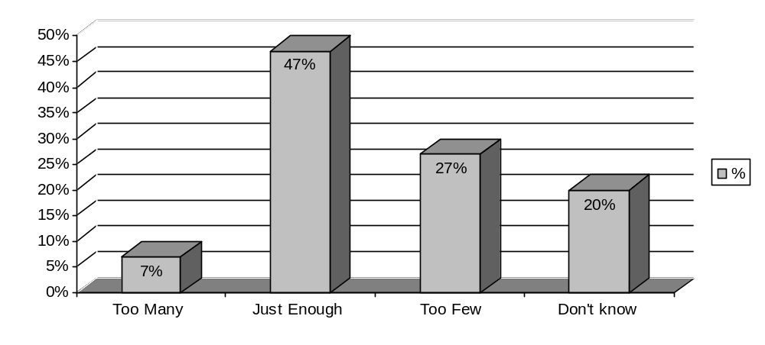 Base: 45

Question 14a: Which of the following types of activities, if any, do you think there should be more of in the park? (Wild About Glasgow, nature walks etc.) (tick all that apply)
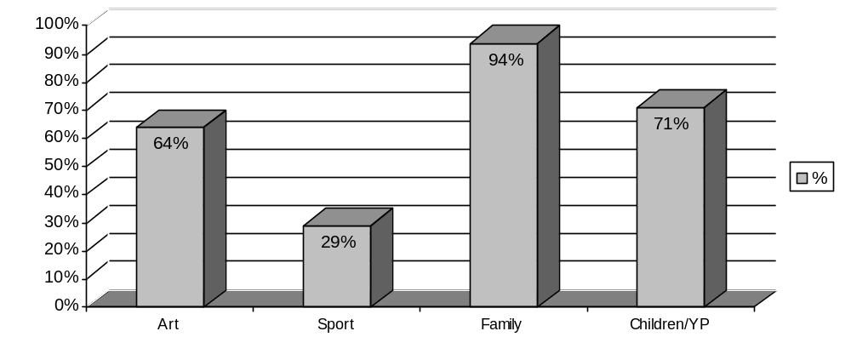Base: 17

7. Park Management and Priorities

Question 15: Please choose from the following list, what you think should be the main priorities for the park. (please select your top three)

The three main priorities highlighted by respondents were:

- Wildlife in parks and green spaces
- Formal gardens
- Trees and woodlands

Other issues identified, included:

- Allotments
- Education activities

Question 16: Please tell us what you like best about the park.

As expected, the formal gardens and botanical collections/displays (glasshouses) were highlighted as the best element of the park. The peace and quiet provided by the park in an urban environment was also mentioned by respondents.

‘Atmosphere, trees, green space, kibble palace, bedding plants,
glasshouses and exhibitions.’

The walks and trails within the park were also seen by respondents as particularly good, specifically the Kelvin walkway.

Question 17: Please tell us what you like least about the park.

Again, as previously mentioned a lack of catering and toilet facilities was highlighted by respondents. Dog and dog fouling was also highlighted as being a problem for some respondents, as well as the use of the park for ball games in areas where it is prohibited.

8. Parks Management Plans

Question 18: Have you read the Park Management Plan?

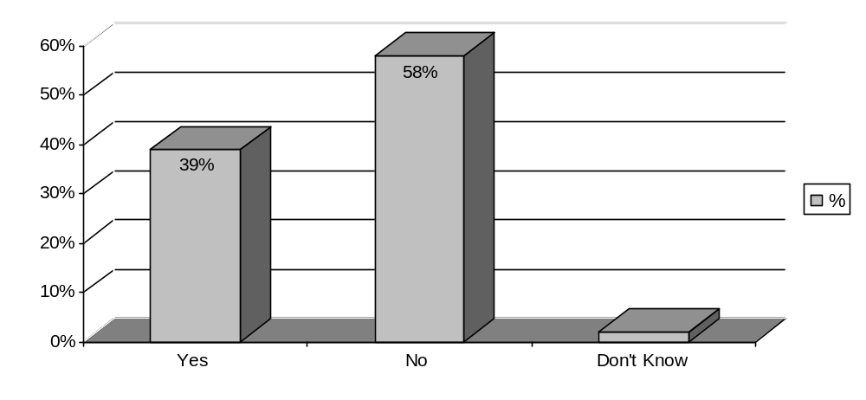 Base: 43

Question 19a: How informative or otherwise did you find the Plan?

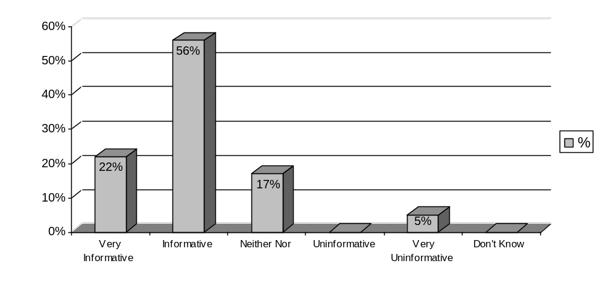Base: 18

Question 19b: If uninformative, what additional information do you think should be included?

Respondent felt that more information would be useful on the future development and promotion of the botanical gardens.

‘More information on how the City intends to promote the main
focus of the Botanical Gardens.’

Question 20: To what extent do you agree or disagree with the following aspects of the Plan?

 | Strongly Agree (%) | Agree (%) | Neither Nor (%) | Disagree (%) | Strongly Disagree (%) | Don’t Know (%)
The Plan was easy to read | 4 (23%) | 6 (35%) | 5 (29%) | 1 (6%) | 1 (6%) | -
The format made it easy to follow | 4 (23%) | 6 (35%) | 5 (29%) | 1 (6%) | 1 (6%) | -
The Plan is comprehensible | 4 (22%) | 7 (39%) | 4 (22%) | 1 (6%) | 2 (11%) | -
The Plan reflects the priorities of the park | 4 (22%) | 6 (33%) | 2 (11%) | 3 (17%) | 3 (17%) | -
Base: 18

9. Park Development
Glasgow City Council is committed to future development of the parks; however, in the current economic climate there are restrictions on the type and size of projects that can be undertaken within the next five years. Nevertheless, this should not prevent any long-term aspirations and so, we would like to hear your ideas.

Question 21: Do you agree or otherwise with the aim to expand the education programme. (Section 2.10.15 Marketing – Education Strategy)
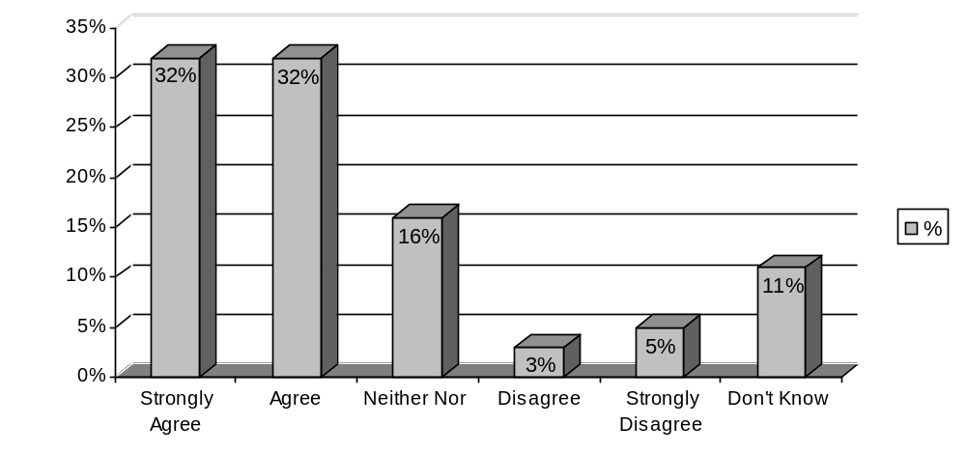 Base: 37

Question 22: Do you have any other comments about the park or the management plan?

A number of issues already mentioned were again highlighted by respondents, including the need for more events and activities. However, it was felt that this should not be done at the expense of the core purpose of the park and botanical collections.

With regards to the old railway station, a number of respondents highlighted that it was part of the park's heritage and should be left as it is, rather than re-developed.
10. About You

Question 23: Gender
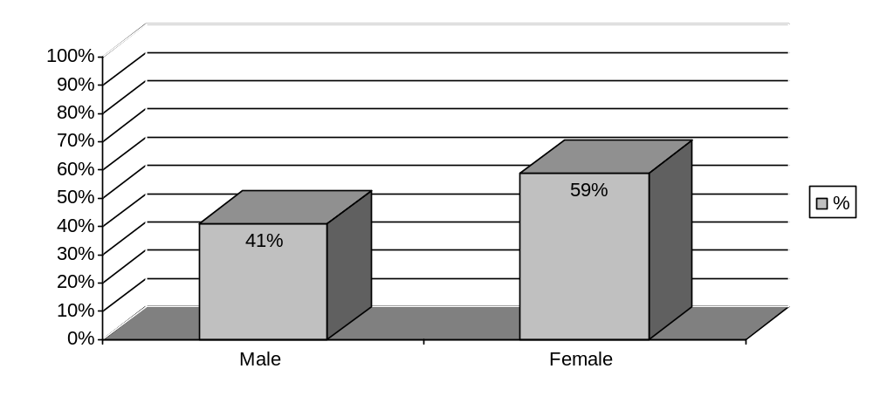Base: 39

Question 24: Age

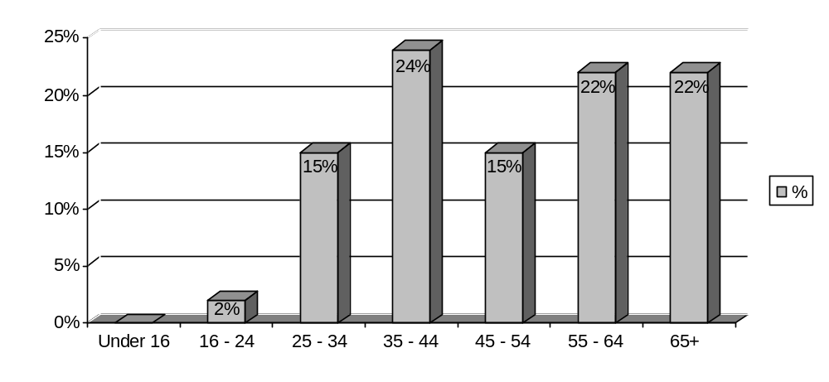 Base: 41

Question 25: Do you have any long-term illness, health problem or disability which limits your activities or the work you can do?
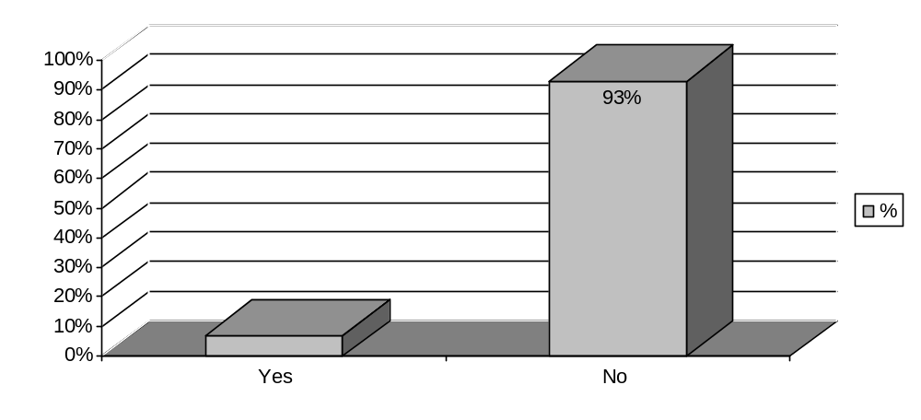 Base: 40

Question 26: How would you best describe you cultural or ethical background?

Cultural/Ethnic Background | Number | Percentage (%)
White Scottish | 30 | 71%
White English | 5 | 12%
White Welsh | - | -
White Northern Irish | - | -
White British | 5 | 12%
White Irish | - | -
Gypsy/Traveller | - | -
Polish | - | -
Pakistani, Pakistani Scottish or Pakistani British | - | -
Indian, Indian Scottish or Indian British | - | -
Bangladeshi, Bangladeshi Scottish or Bangladeshi British | - | -
Chinese, Chinese Scottish or Chinese British | - | -
African, African Scottish or African British | - | -
Caribbean, Caribbean Scottish or Caribbean British | - | -
Black, Black Scottish or black British | - | -
Arab | - | -
Other | 2 | 5%
Base: 42

